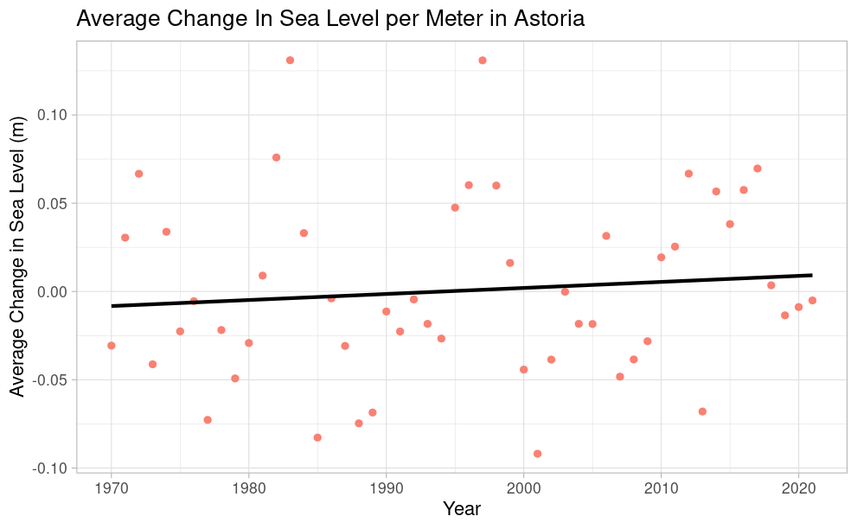

ggplot(Astoria_Avg,aes(x=Year,y=Avg))+

geom_point(color="salmon")+

labs(title="Average Change In Sea Level per Meter in Astoria",y="Average Change in Sea Level (m)")+

theme_light()+geom_smooth(method="lm",color="black",se=FALSE)

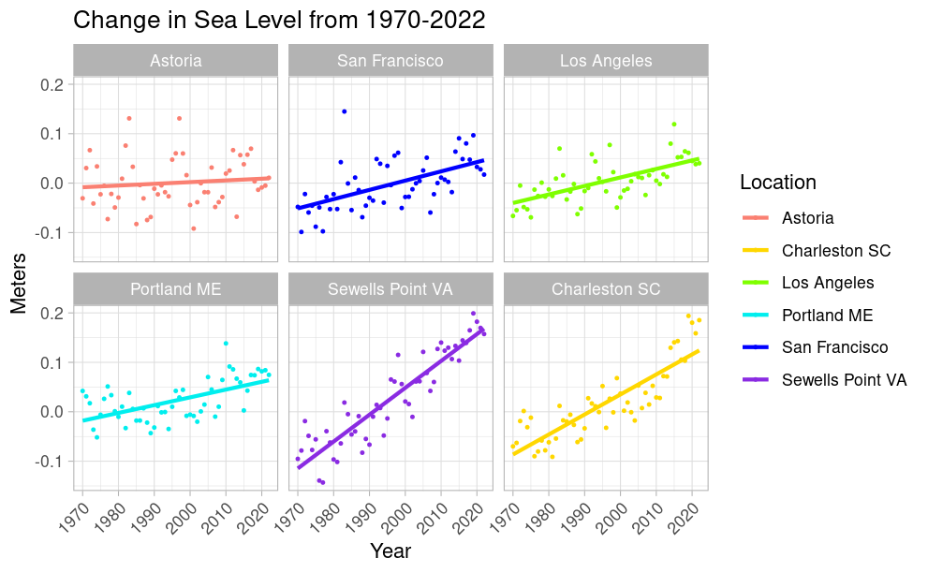

ggplot(Trend, aes(x = Year, y = Avg, color = Location)) +

geom_point(size=0.5)+ geom_smooth(method = lm, se = FALSE)+

facet_wrap(vars(Location))+

facet_wrap(. ~ factor(Location, levels = c("Astoria", "San Francisco", "Los Angeles","Portland ME","Sewells Point VA","Charleston SC")))+

scale_color_manual(values = c(

"Astoria" = "salmon",

"Charleston SC" = "gold",

"Los Angeles" = "chartreuse",

"Portland ME" = "cyan2",

"San Francisco" = "blue",

"Sewells Point VA" = "blueviolet")) +

theme_light()+

labs(title="Change in Sea Level from 1970-2022",x="Year",y="Meters")+

theme(axis.text.x = element_text(angle = 45, hjust = 1))

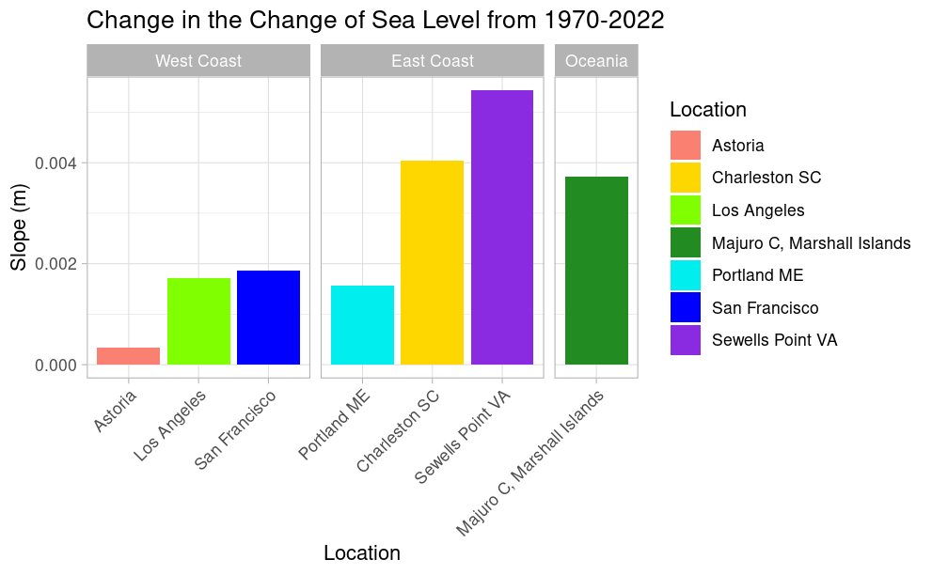

Avg %>%

split(.$Location) %>%

map(~lm(Avg ~ Year, data = .x)) %>%

map_df(broom::tidy, .id = 'Location') %>%

filter(term == 'Year')%>%

mutate(Region=case_when(Location %in% c("Astoria","Los Angeles","San Francisco")~"West Coast",Location %in% c("Charleston SC","Sewells Point VA", "Portland ME")~"East Coast",Location %in% c("Majuro C, Marshall Islands")~"Oceania"))%>%

ggplot(aes(x = reorder(Location, estimate), y = estimate, fill=Location)) +

geom_col(position="dodge")+theme_light()+

labs(x="Location", y="Slope (m)",

title="Change in the Change of Sea Level from 1970-2022")+

facet_grid(. ~ factor(Region, levels = c("West Coast", "East Coast", "Oceania")), drop = TRUE, scales = "free_x", space = "free") +

scale_fill_manual(values=c("Astoria"="salmon", "Charleston SC"="gold",

"Los Angeles"="chartreuse","Portland ME"="cyan2",

"San Francisco"="blue","Sewells Point VA"="blueviolet",

"Majuro C, Marshall Islands" = "forestgreen")) +

theme_light() +

theme(axis.text.x = element_text(angle = 45, hjust = 1))